**CITY OF LAKE CHARLES, LOUISIANA   
2019 ANNUAL ACTION PLAN**

**SUBSTANTIAL AMENDMENT**

**DRAFT**

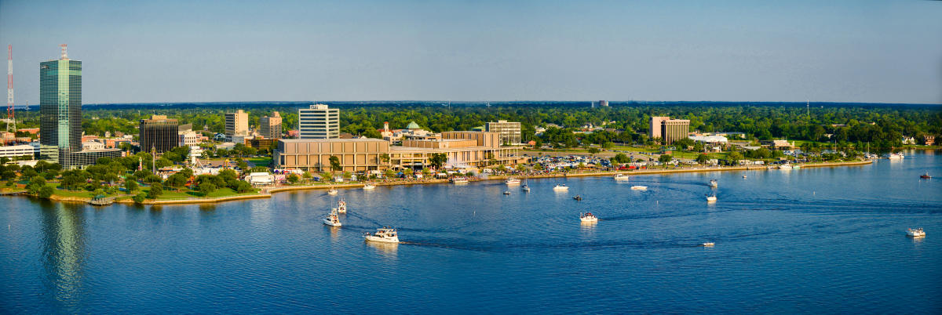

Prepared By

The City of Lake Charles

Community Development Department

April 2024